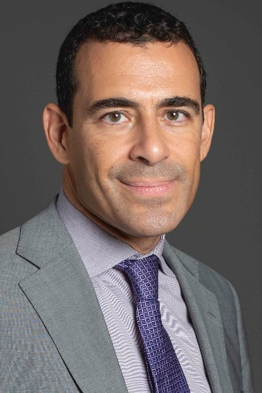

Spyros Antonelos is the ECA region Mediation Officer of the World Bank Group since June 2019 after a multifaceted international career:
A Greek Lawyer having studied and worked in France, the U.K., Belgium and Greece for 20 years, he became a Mediation pioneer in his country since 2008 after receiving his mediator’s accreditation from CIArb (U.K.).
He was also trained in the U.S. (Pepperdine University) on a Weinstein JAMS Fellowship in 2013.
In 2014 he created and co-managed the RESOLVE Mediators leading Greek ADR firm (www.resolve.gr).
From 2016 to 2019 Spyros created and directed the Athens SMEs Chamber Mediation Centre (www.diam-acsmi.gr) parallel to teaching Mediation and Negotiations at MEF University (Istanbul).
As a Trainer, he has trained hundreds of mediators and lawyers in mediation, collaborating with various Greek and foreign Bar Associations.
Spyros advised the Greek Ministry of Justice (2012-2018) and is the co-Author of 2 reference Mediation Books in Greek.

